Client Education Meeting
what’s new at Oxford Bovine?
All the staff at Oxford Bovine hope you had a wonderful Christmas season and a Happy New Year. We look forward to working with you in 2020.

We would like to welcome Courtney Swann to the Oxford Bovine Team. Courtney is our second vet tech and will also be splitting her time between the office and on farm work. She brings with her a lot of experience in calf management, breeding, and embryo implantation.

We are now carrying a new tube feeder that has a 4L hard bottle with a solid stainless steel probe. It is easy to clean and the large bore probe makes it perfect for feeding thick colostrum quicker.
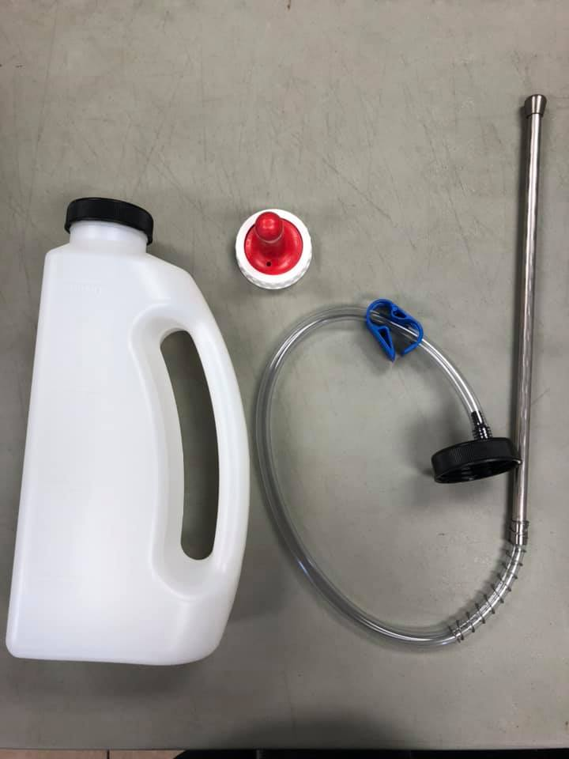

  - Oxford Bovine Veterinary Professional Corporation

Cow Tails

We are excited to be hosting a client education day on February 6th, 2020 at the Woodstock Quality Inn. We have arranged Dr. Juilo Giordano from Cornell University’s department of Dairy Cattle Biology and Management to speak. He specializes in dairy cattle reproduction, health, and the implications of herd performance on the economics of dairy farms. He will be speaking on topics including heifer reproduction, the newest in dairy repro research, and the economic impact of various voluntary waiting periods. We also have Dr. Ann Godkin speaking as an independent consultant for the DFO’s selective dry cow therapy project. She will be leading a discussion on the criteria for selective dry cow therapy and mitigating potential risks.

9:30- Coffee and Welcoming
10:00- Dr. Ann Godkin: DFO’s Selective Dry Cow Therapy Project
11:00- Bethany Muir with Zoetis: Smartbow
11:15- Refreshment Break
11:30- Dr. Julio Giordano: Current and Future Opportunities in Reproductive Management of Dairy Cattle
12:30- Hot lunch
1:15- Dr. Julio Giordano: Opportunities and Challenges of Automated Technologies for Health Monitoring and Management.
2:30- Adjourn and Safe Travels

If you are interested in attending please contact the office directly to RSVP by January 27th, 2020. 519-423-6706

Thank you to Zoetis for sponsoring the event!

Changes to Animal Transport Regulations

Starting February 20th, 2020 the amended Health of Animal Regulation will come into effect.

- Calves 8 days old or less will no longer be able to be shipped to a sales barn or assembly centre. You are allowed to move calves 8 days or less (just not to a sales barn or assembly centre) but they require space to lie down and must be separated from calves over 8 days old. This will have an impact on calf management. Be sure to have extra hutches, bedding, and feed to house bull calves the extra days. Also, ensure the staff responsible for calves are prepared for the increased workload.

- Calves over 8 days old must not be transported for longer than 12 hours. The times starts from the time that the first calf is loaded. After 12 hours they require feed, water and rest. Calves’ navels must be healed and uninfected, the calf cannot have a fever or be dehydrated, and it must have been given feed and water before transport.

- New regulations classify animals as “compromised” or “unfit”. Compromised animals CANNOT be sent to a sales barn or assembly yard and must be sent direct to slaughter. Unfit animals must not be transported( unless for veterinary care). Below is a chart describing some of the conditions in each category.
Compromised | Unfit
MIld Lameness | LAMENESS WITH SIGNS OF PAIN, NON WEIGHT BEARING, RELUCANT TO WALK
MINOR VAGINAL OR RECTAL PROLAPSE | SEVERE VAGINAL OR RECTAL PROLAPSE
*pEAK LACTATION ANIMALS | DEHYDRATION
UNHEALED surgical WOUNDS FOLLOWING A PROCEDURE | IN THE LAST 10% OF PREGNANCY OR WITHIN 48 HOURS AFTER GIVING BIRTH
PREVENTATIVE HOBBLES | LABOURED BREATHING

*lactating animals that can be milked at regular intervals are not considered compromised. Peak lactation animals that cannot be milked at regular intervals and become engorged are considered compromised.
what have we been up to?
Kady and Courtney have been busy this fall attending multiple conferences including the Ontario Calf Health Improvement Workshop. They learned a lot on calf management and how best to service client’s calf health needs.
Dr. Matthew Walker has been on Holstein Canada’s Breed Advisory Committee.
Drs. Lisa Sharko and Dave Carson attended a meeting on transition cow DCAD diets and the positive impact on fresh cow health.
Dr. Eric Perrin attended this fall’s Ontario Association of Bovine Practitioners meeting on the sustainability of the dairy industry.
Dr. Frank Jongert went to a conference in Colorado for updates regarding embryo transfer.
Please ask us about what we are learning!

